
American International University – Bangladesh
Faculty of Engineering
Department of EEE & CoE

MICROPROCESSOR & EMBEDDED SYSTEM PROJECT PROPOSAL FORM
- SEMESTER: Fall 2021-2022

PROJECT TITLE: Automatic water level indicator in the crop field using Arduino
- Survey to develop process for complex engineering problems considering cultural and societal factors (use pie chart): 5 MARKS
- GOALS AND BENEFITS OF PROJECT: 4 MARKS
- PROTOTYPE BLOCK DIAGRAM: 4 MARKS
- PROJECT TIMELINE (GANTT CHART): 5 MARKS

- SURVEY TO DEVELOP PROCESS FOR COMPLEX ENGINEERING PROBLEMS CONSIDERING CULTURAL AND SOCIETAL FACTORS (USE PIE CHART):
The survey was conducted among a group of 49 people. Each of them was asked seven questions for which they had to choose yes or no or others. The pie charts show the results of each question.
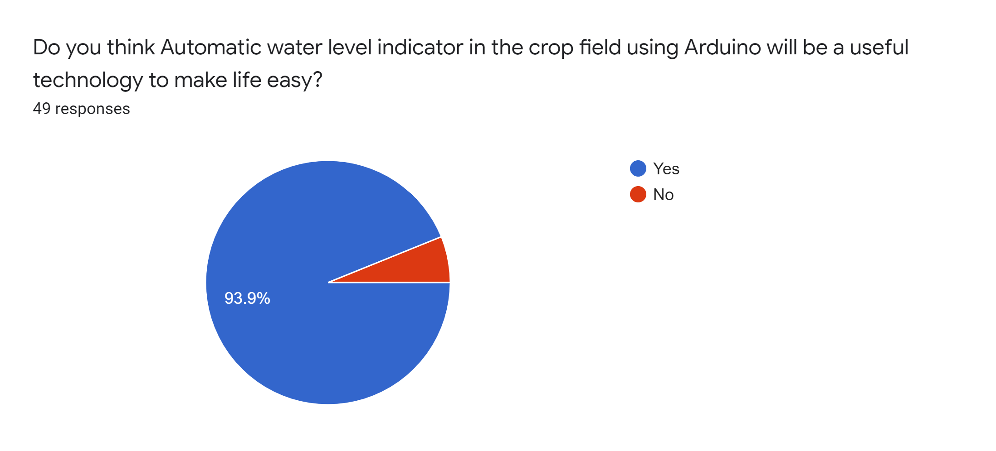
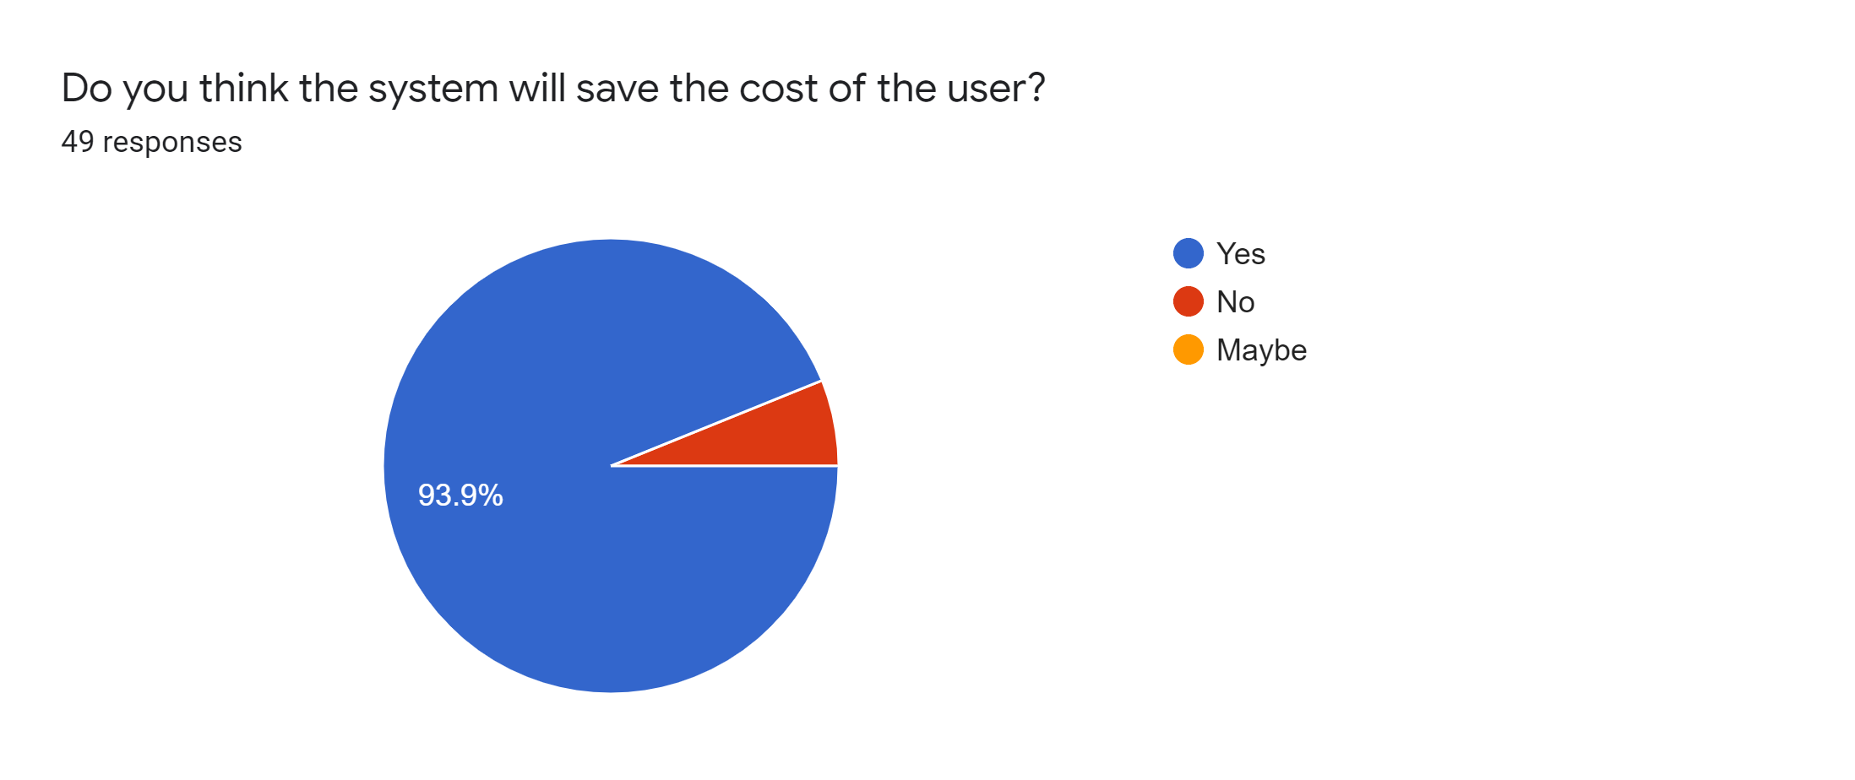
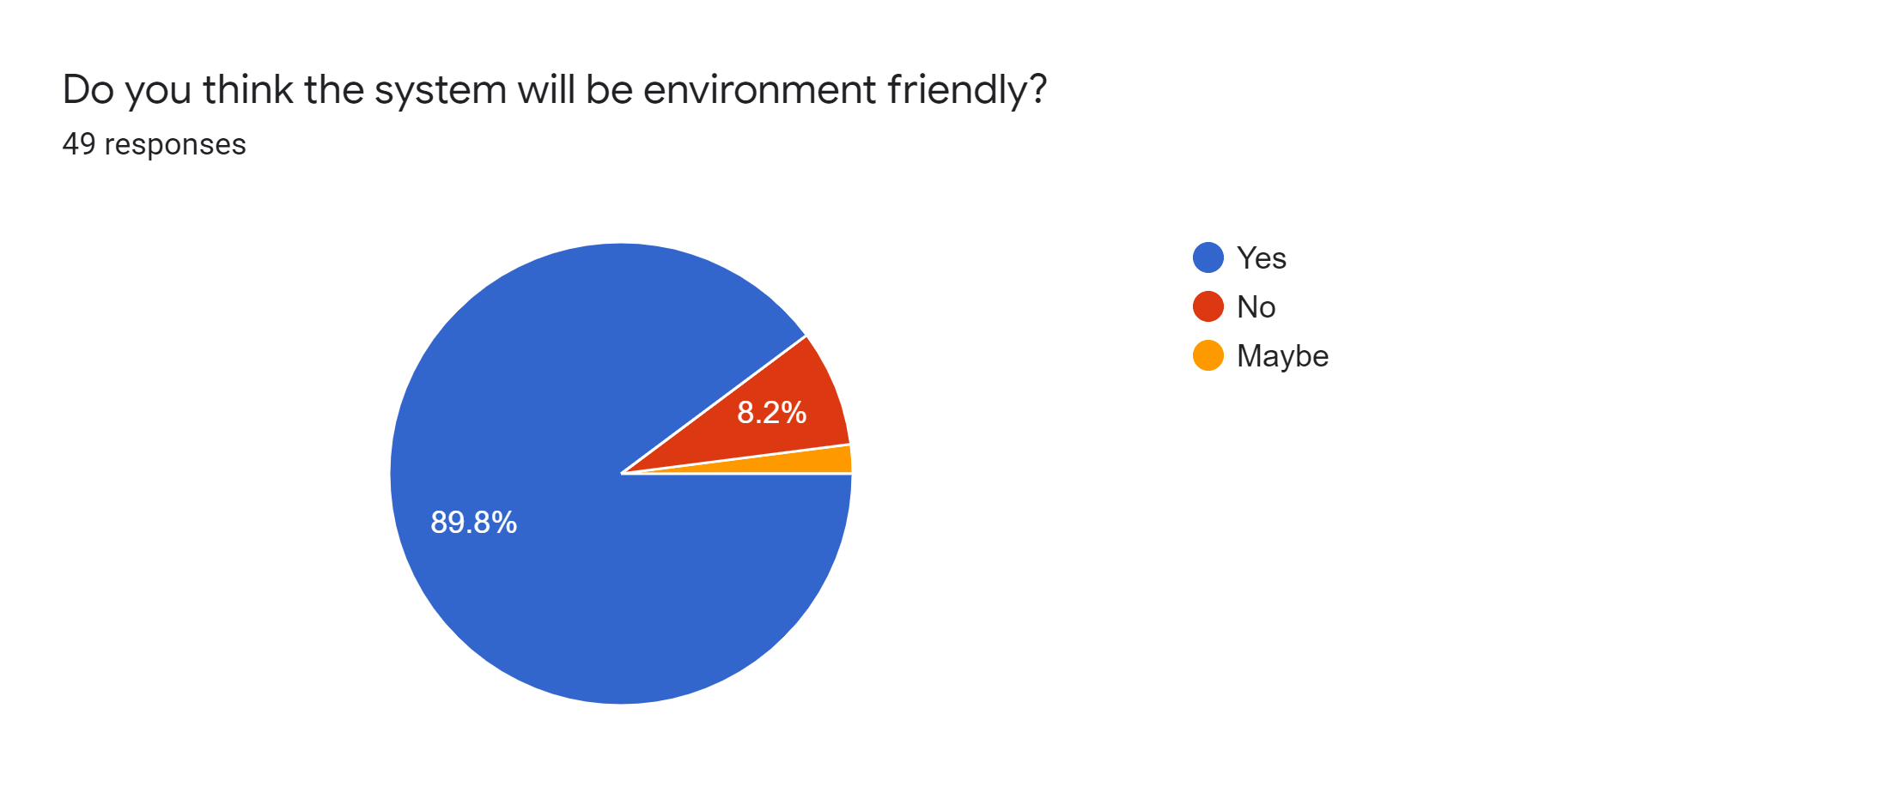
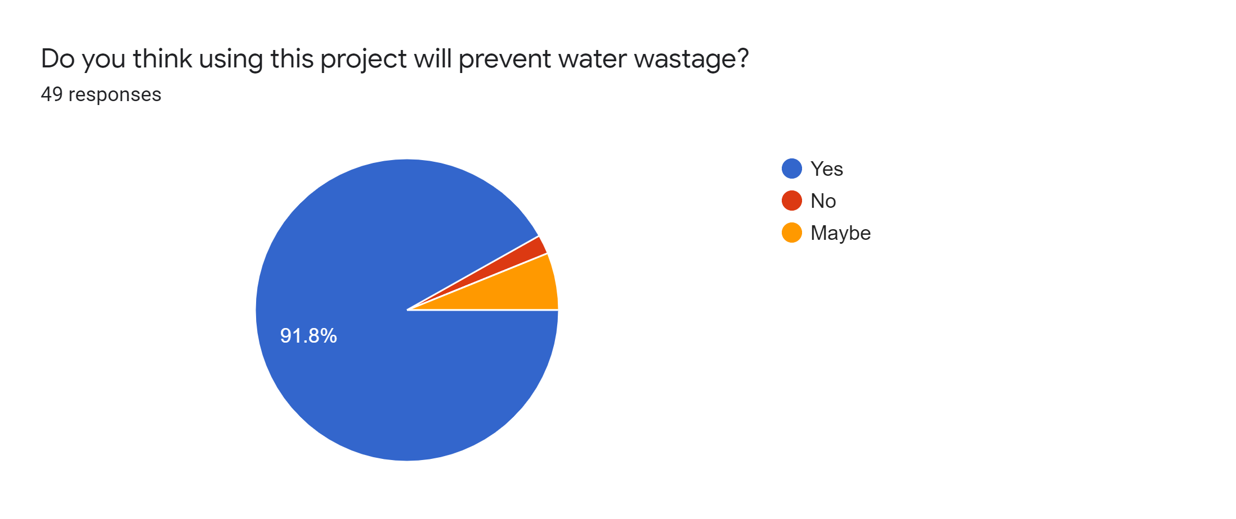
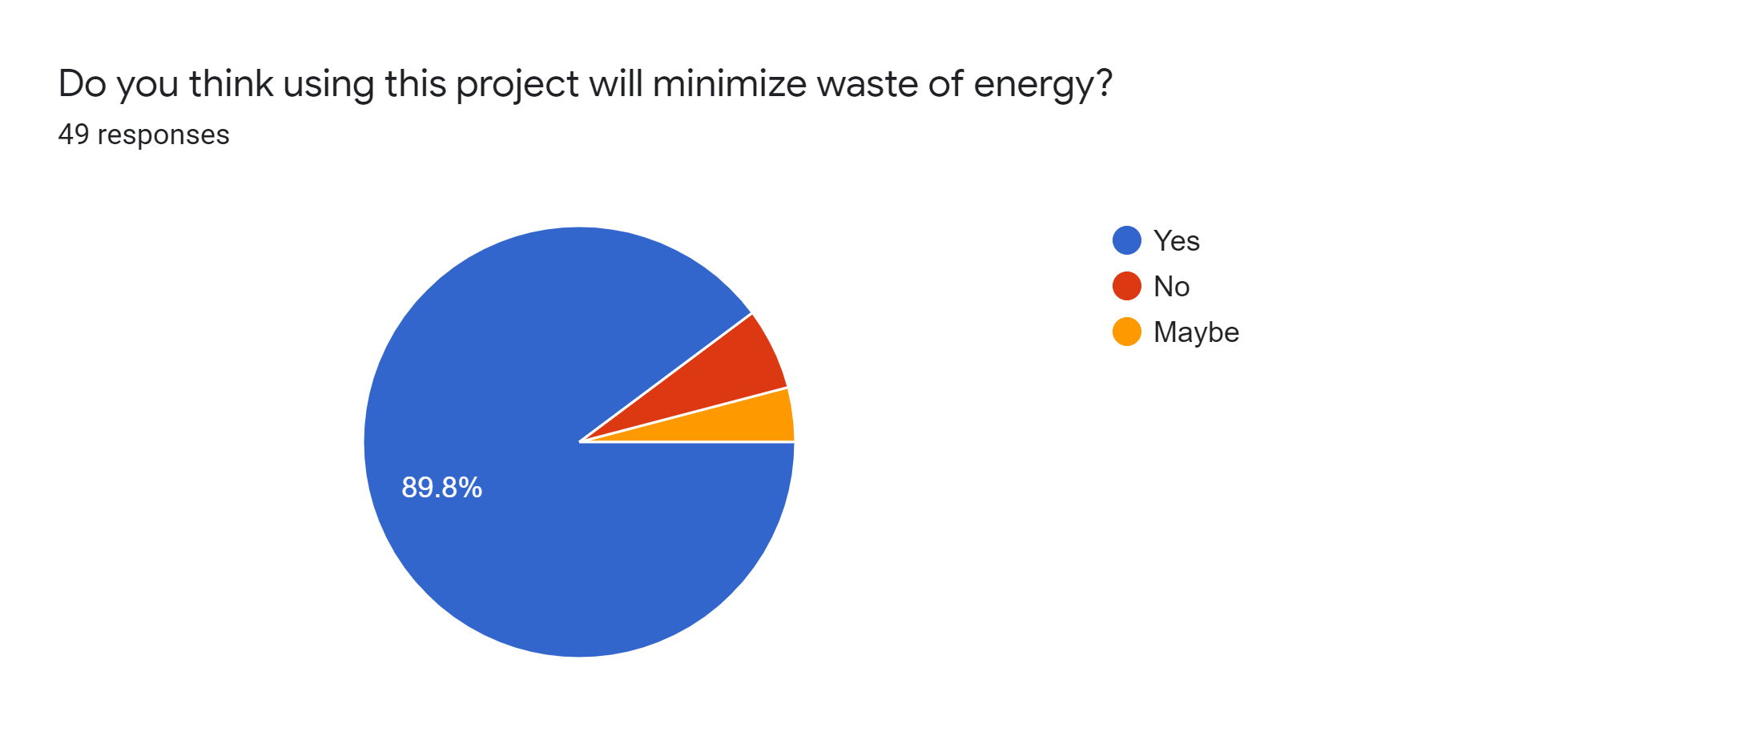
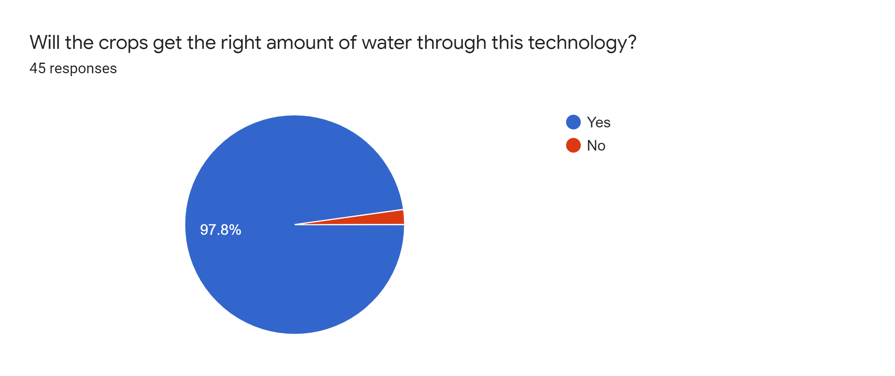
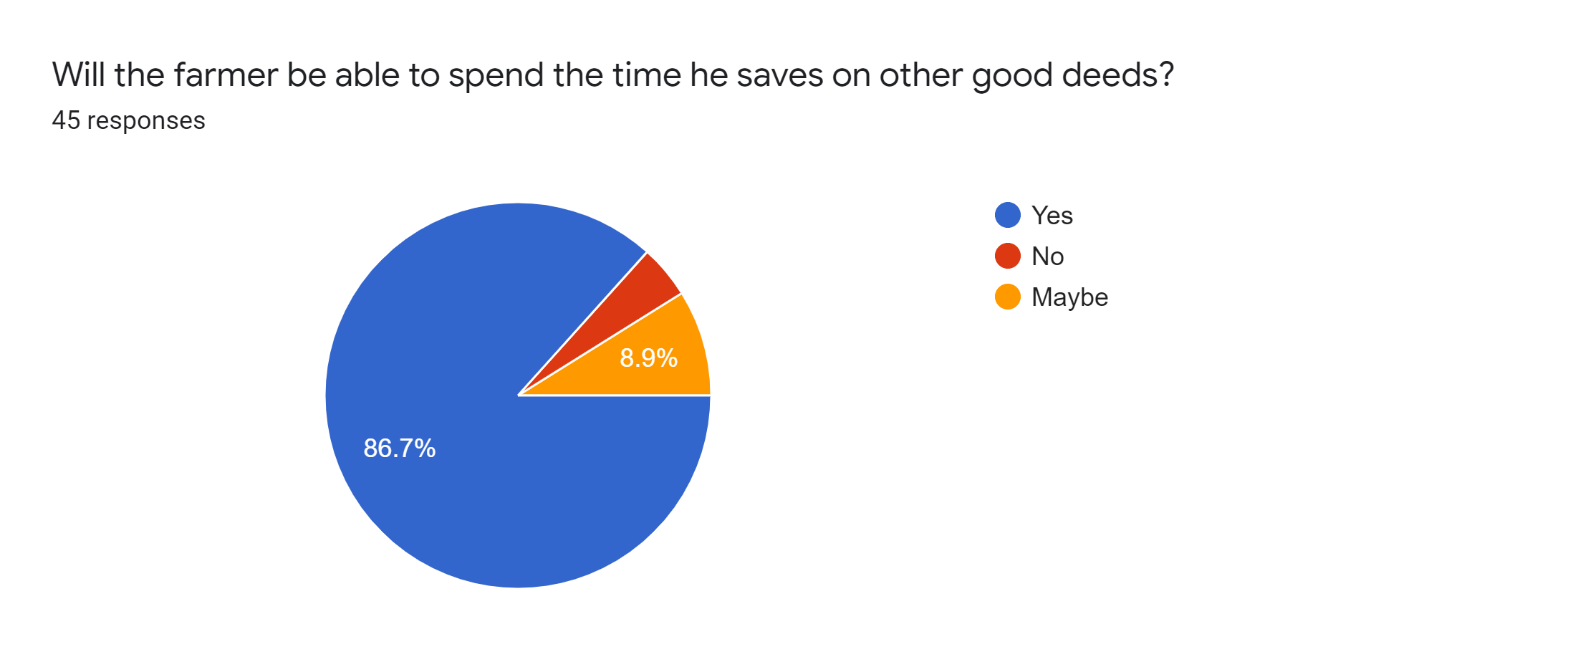

2. GOALS AND BENEFITS OF PROJECT:
This project is about automatic water level indicator in irrigation using Arduino. The main feature of the system is to detect the level of water in the crop field. There will be a water pump for the water source, a water exhaust motor and sensor to monitor the level of water in the crop field.
The Goals of the project-
i. To prevent the excessive amount of water in the crop field.
ii. If there is heavy amount of rain, by using this technology it will help to control the water level.
iii. If there is high water level reading in the sensor, it will lower the extra amount of water by pumping it through the motor.
iv. If there is lower level of water, it will increase the level of water by pumping more water.
Benefits of the project-
i. It will help to decrease the water wastage.
ii. There will be less energy loss.
iii. To minimize human errors.

3. BLOCK DIAGRAM:
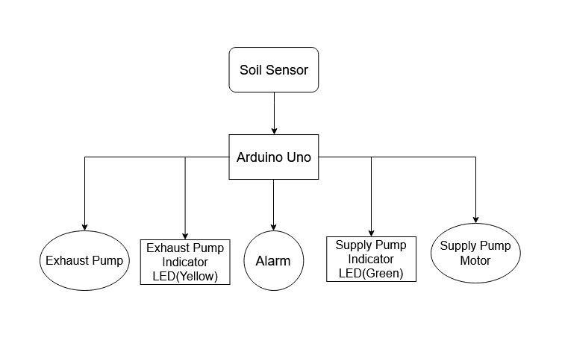
4.GANTT CHART
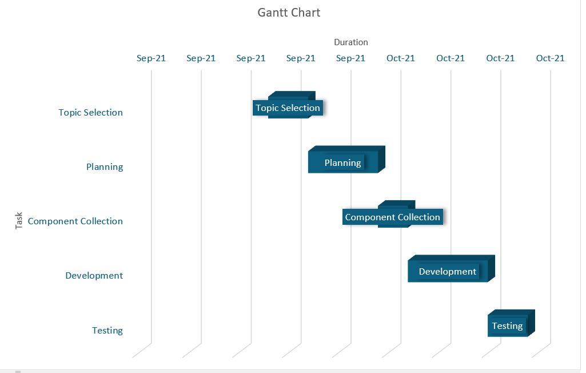

FOR FACULTY USE ONLY
COMMENTS BY COURSE TEACHER:

COURSE TEACHER’S NAME COURSE TEACHER’S SIGNATURE DATE

GROUP MEMBERS
(Maximum 8 students are permitted to carry out a single Project. However, depending on the capability of the students, 5 number of students may be allowed but not less than that)

NAME: Chowdhury Ananya  ID: 18-39028-3  PROGRAM: CSE  EMAIL: ananyachy2001@gmail.com | NAME: JOY KARMOKAR  ID: 18-39263-3  PROGRAM: CSE  EMAIL: joykormokar7@gmail.com
NAME: Durjoy Dey  ID: 18-39013-3  PROGRAM: CSE  EMAIL: durjoydey77.dd@gmail.com | NAME: Sahara, Salma Jahan  ID:18-38788-3  PROGRAM: CSE  EMAIL: saharasayed5@gmail.com
NAME: Pia,Tonima Hossain  ID: 18-38892-3  PROGRAM: CSE  EMAIL: tonimapia12@gmail.com | NAME: Farabi, Sazid Al  ID: 19-39478-1  PROGRAM: CSE  EMAIL: farabial54@gmail.com
NAME: Rokon,Nurul Huda Bhuiyan  ID: 18-38983-3  PROGRAM: CSE  EMAIL: bhuianrokon003@gmail.com | NAME: Joba, Sharika Parvin  ID: 18-38721-3  PROGRAM: CSE  EMAIL: sharikajoba@gmail.com
REMARKS (for OFFICE use only)

